Data and text mining
Virtual screening of an orexin receptor ligand library identifies lemborexant analogs with favorable CNS drug-likeness and dual-receptor binding profiles
Holly Erskine
Abstract
Orexin receptor modulators (ORMs) are an emerging class of drugs that address insomnia using mechanisms distinct from those of conventional GABAergic sedatives. The unmet demand for safer insomnia drugs, especially in vulnerable populations such as patients with dementia, has brought ORMs into the spotlight. ORMs are also showing promise for treating type 1 narcolepsy. To further study ORMs, a PubChem-derived library of 80 structural analogs of four known orexin ligands was assembled, deduplicated into 79 unique compounds, and subjected to physicochemical filtering (Ro5), in silico ADMET prediction, and a composite CNS-weighted scoring scheme prioritizing BBB penetration. The top 20 candidates were docked against OX1R and OX2R crystal structures. Seventy-eight of 79 compounds satisfied Lipinski's criteria. Lemborexant-derived analogs dominated the shortlist, with seven analogs exceeding lemborexant in composite score. One analog (CID 56944043) achieved the most balanced dual-receptor binding profile (OX1R −8.796 kcal/mol, OX2R −7.780 kcal/mol), while three suvorexant-derived analogs failed to locate either binding pocket. A significant negative correlation between CNS drug-likeness and OX1R docking score (ρ = −0.54), and a positive correlation between OX1R affinity and predicted hERG liability (ρ = 0.58, p = 0.008) were observed. This pipeline effectively prioritized CNS-relevant orexin ligands while revealing a trade-off between BBB-oriented drug-likeness and receptor engagement, identifying safety considerations for high-affinity OX1R binders. All code and data are available at https://github.com/TheoreticalHarpist/orexin-ligand-virtual-screening

Keywords: orexin receptor · molecular docking · virtual screening · ADMET prediction · lemborexant· CNS drug discovery
1. Introduction
In 1998, the orexin (hypocretin) system was identified as a central arousal hub that promotes wakefulness, stabilizes sleep-wake transitions, and regulates attention and appetite. Two neuropeptides, orexin A and orexin B, which are primarily produced by neurons in the lateral hypothalamus, signal through OX1R and OX2R, two G protein-coupled receptors (GPCRs), which are expressed widely throughout the CNS. Orexin A binds both receptors with approximately equal affinity, whereas orexin B preferentially engages OX2R (Smart et al., 1999). In narcolepsy type 1, orexin deficiency causes profound hypersomnolence and fragmented sleep.
Sleep disturbance is also prevalent in dementia, yet conventional sedative-hypnotics carry substantial risks including amnesia, falls, dependence, and concerns about impaired glymphatic clearance (Hauglund et al., 2025; Gayger-Dias et al., 2026). Dual orexin receptor antagonists (DORAs)—suvorexant, lemborexant, and daridorexant—offer an alternative mechanism of inhibiting wakefulness without potentiating sedation, with lower risks of cognitive and motor side effects (Żełabowski et al., 2025) and a potentially safer glymphatic profile (Ragsdale et al., 2025; Järvelä et al., 2025).
Orexin receptor agonists address the opposite clinical problem: oveporexton, still in clinical testing, restores deficient orexin signaling in narcolepsy type 1 (Arif et al., 2026), without the unforeseen hepatotoxicity that halted an earlier trialed agonist (Dauvilliers et al., 2025). This clinical history highlights the necessity of safety screening in orexin ligand discovery.
OX1R and OX2R represent a significant class of drug targets, with over 30% of approved drugs acting on GPCRs (Majumdar et al., 2024). A well-established efficiency gain in GPCR drug discovery is virtual screening, which assembles large chemical libraries prior to costly experiments. Targeting CNS-based receptors imposes constraints: molecular size, lipophilicity, and polarity must favor blood-brain barrier (BBB) permeation. Additionally, the nearly-identical binding pockets of both receptors, which differ by only a few residues, complicate selectivity design (Rappas et al., 2020). Although the functions of both receptors overlap, OX1R primarily drives arousal and stress responses, whereas OX2R mainly regulates sleep-wake cycles and metabolic homeostasis (Mieda et al., 2013). Dual inhibition remains the preferred approach for insomnia, however, selective OX2R activation is favored for treating narcolepsy. Available crystal structures (PDB: 4ZJC and 4S0V) have supported virtual docking studies (Sena et al., 2025), helped identify a selective OX1R ligand (Hellmann et al., 2020), and enabled the discovery of plant-derived dual antagonists (He et al., 2023).
Prior computational studies have employed traditional Chinese medicine compound databases (He et al., 2023) and structure-based design from known scaffolds (Hellmann et al., 2020), but automated similarity-based library construction from approved DORA and agonist seeds combined with CNS-weighted ADMET filtering and dual-receptor docking has not been reported.
To address this gap, a PubChem-derived library of putative orexin receptor ligands was assembled using similarity-based chemical mining. The chemical structures of all four seed compounds are shown in Figure 4A. After CNS-aware filters and composite ADMET scoring was applied, candidate drugs were docked against OX1R and OX2R. The goal was to identify candidate compounds with favorable CNS drug-likeness profiles and competitive predicted binding affinities at either or both receptors.
2. Methods
2.1 Ligand library construction
The workflow is summarized in Figure 1. Seed compounds (Figure 4A) daridorexant, lemborexant, suvorexant (approved dual orexin receptor antagonists) and the orexin receptor agonist oveporexton (in clinical development for narcolepsy type 1) were retrieved from PubChem (Kim et al., 2023) via pubchempy (v1.0.4) using name-based queries to the PubChem PUG REST API. Because pubchempy’s similarity search wrapper does not accept CID-based queries, structural analogs were identified by querying PubChem's fast 2D fingerprint similarity endpoint (fastsimilarity_2d) directly via the REST API using each seed's PubChem CID, with a Tanimoto threshold of 0.85 and a 20-result limit per seed. Retrieved fields included molecular weight, XLogP, H-bond donor/acceptor counts, rotatable bonds, TPSA, and isomeric SMILES. SMILES strings were retrieved in a secondary step via direct PubChem REST API queries, as the relevant pubchempy attributes were deprecated in the version used. Records were aggregated and deduplicated by PubChem CID, yielding an initial library of 80 compounds. Nomenclature tracked both seed scaffolds and their analogs by listing seeds and their analog CIDs in the name of a ligand: “similar_to_{seed_CID}_{analog_CID}”. CIDs for seeds are: daridorexant: 91801202; lemborexant: 56944144; suvorexant: 24965990; oveporexton: 154617563. Thus a molecule with a CID of 67473934 that has a lemborexant scaffold is labeled “similar_to_56944144_67473934”.

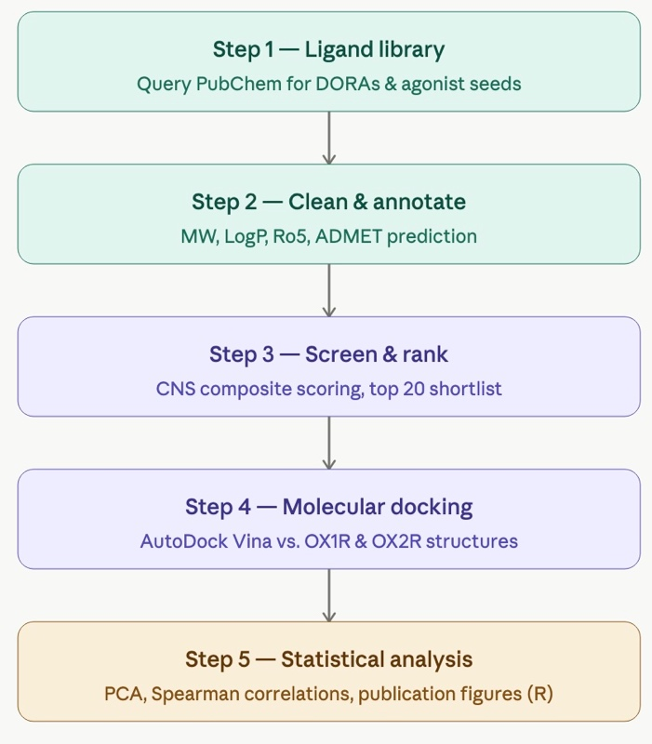

Figure 1. Overview of the five-step computational pipeline for orexin receptor ligand virtual screening. Steps 1–2 (teal) cover library construction and annotation; Steps 3–4 (purple) cover candidate prioritization and molecular docking; Step 5 (amber) covers statistical analysis and visualization.

2.2 Physicochemical filtering
Compounds lacking SMILES or molecular weight were removed. Duplicates were removed by PubChem CID. Salt forms were identified and stripped using RDKit's SaltRemover and SMILES were canonicalized; one compound (daridorexant hydrochloride) was removed, reducing the library to 79 unique compounds. Lipinski Rule-of-5 (Ro5) violations were computed (MW > 500, XLogP > 5, H-bond donors > 5, H-bond acceptors > 10) and supplemented with TPSA>140 Å2 and rotatable bonds>10. A cumulative-violation count was recorded; compounds with ≤1 violation were considered Ro5-passing. Of 79 compounds, 78 (98.7%) met this criterion; MW was the most frequently violated parameter (7 compounds).

2.3 ADMET prediction
In silico ADMET endpoints were predicted from isomeric SMILES using admet-ai (Swanson et al., 2024) and appended to the dataset. Retained endpoints included HIA_Hou, Pgp_Broccatelli, BBB_Martins, CYP2D6_Veith, CYP3A4_Veith, hERG probability, Ames mutagenicity probability, LD50_Zhu, Caco2_Wang, and Solubility_AqSolDB.

2.4 Composite scoring and ranking
Scoring weights were assigned based on CNS pharmacokinetic criteria described by Wager et al. (2010), with BBB penetration weighted most heavily given the hypothalamic localization of orexin receptors. A weighted composite drug‑likeness score (range 0–1) combined eight physicochemical and ADMET-derived metrics (Table 1). BBB_Martins received the highest weight (0.25); hERG and Ames liabilities were incorporated as inverse probabilities (1 − P). Other weights: XLogP 0.15, TPSA 0.15, hERG 0.15, MW 0.10, H-bond donors 0.10, AMES 0.05, rotatable bonds 0.05. The top 20 ranked compounds were selected for molecular docking.
Table 1. Scoring criteria and weights applied to rank candidate compounds for molecular docking. hERG and AMES safety scores were computed as 1 minus the predicted probability of liability.
Property | Score 1.0 | Score 0.6–0.7 | Score 0.4–0.5 | Score 0.1–0.2 | Weight
BBB penetration (BBB_Martins) | Continuous probability (0–1) | — | — | — | 0.25
XLogP | 1–4 | 0–1 or 4–5 | — | <0 or >5 | 0.15
TPSA (Å²) | ≤70 | 70–90 | 90–120 | >120 | 0.15
hERG safety | 1 − P(hERG) continuous | — | — | — | 0.15
Molecular weight (Da) | 300–450 | 200–300 or 450–550 | — | <200 or >550 | 0.10
H-bond donors | 0 | 1 | 2 | >2 | 0.10
Mutagenicity safety (AMES) | 1 − P(AMES) continuous | — | — | — | 0.05
Rotatable bonds | ≤5 | ≤8 | ≤10 | >10 | 0.05
Total weight |  |  |  |  | 1.00

2.5 Molecular docking
Docking used AutoDock Vina v1.2.7 (Trott & Olson, 2010; Eberhardt et al., 2021). OX1R (PDB: 4ZJC) and OX2R (PDB: 4S0V) structures were downloaded from the RCSB PDB. Receptor preparation (Open Babel v3.1.0) removed waters and non-protein fragments, added polar hydrogens, and converted to PDBQT; receptors were treated as rigid. Binding site centers were defined programmatically as the centroid of co-crystallized ligand heavy atoms (4OT in 4ZJC; SUV in 4S0V), yielding coordinates of X=−7.49, Y=0.24, Z=−54.15 Å for OX1R and X=52.46, Y=7.97, Z=53.44 Å for OX2R. Search boxes were 20×20×20 Å for both receptors. Ligands were generated from SMILES with Open Babel and minimized using the MMFF94 force field (500 steps), then converted to PDBQT. Docking used exhaustiveness = 8 and up to 9 binding modes; the best-scoring pose (most negative ΔG) per compound–receptor pair was retained. Per-compound metrics included OX1R and OX2R docking scores, average docking score, and selectivity index (ΔG_OX1R − ΔG_OX2R).

2.6 Statistical analysis and visualization
Final docking results were analyzed in R (v4.5.0) using tidyverse, ggpubr, factoextra, corrplot, ggrepel, patchwork, and rstatix. Compounds were grouped into three class levels: DORA, DORA_analog, and agonist_analog. Descriptive statistics (mean ± SD) were computed for molecular weight, XLogP, TPSA, BBB penetration, AMES mutagenicity, and docking scores by drug class.
Visualizations included box plots comparing OX1R and OX2R docking scores by structural class, an OX1R versus OX2R scatter plot with a line of equal affinity and labels for top-scoring compounds, a principal component analysis (PCA) of eight molecular and docking features with a 95% confidence ellipse for the DORA analog class, and a Spearman correlation matrix of nine physicochemical and docking properties. Spearman rather than Pearson correlations were used throughout given small sample sizes and non-normal score distributions. All figures were exported at 300 dpi.
Inferential tests comprised two-sided Wilcoxon rank-sum tests comparing OX1R and OX2R docking scores between DORA and DORA_analog groups, and two-sided Spearman correlation tests assessing associations of molecular weight and hERG liability with OX1R docking score.
Reproducibility: All code and data are available at https://github.com/TheoreticalHarpist/orexin-ligand-virtual-screening

Results
3.1 Library Composition and Drug-Likeness
Structural similarity searches seeded with four orexin receptor ligands (three approved DORAs: daridorexant, lemborexant, suvorexant; one agonist in clinical development: oveporexton) retrieved 80 compounds from PubChem using a Tanimoto similarity threshold of 0.85. Following removal of one salt (daridorexant hydrochloride) and deduplication, 79 unique compounds remained. The library demonstrated strong drug-likeness, with 78 of 79 compounds (98.7%) satisfying Lipinski's Rule of Five criteria; molecular weight was the most frequently violated parameter (7 compounds exceeding 500 Da).
All structural classes demonstrated favorable predicted BBB penetration with the mean probability across the full 79-compound library = 0.79 (Table 2). Agonist analogs achieved the highest class mean (0.881), better than the known DORAs (0.812). Oveporexton scored more modestly (0.718). Daridorexant, despite being an approved CNS drug, scored the lowest predicted BBB penetration among seeds (0.669), suggesting a possible limitation of the prediction model.
Predicted mutagenicity (AMES) differed markedly between structural classes, with DORA and DORA analog classes showing substantially lower mean values (0.197 and 0.280 respectively) compared to the agonist class (oveporexton: 0.713; agonist analogs: 0.701 ± 0.157), suggesting a potential safety distinction between the two pharmacological classes. Mean composite drug-likeness scores were comparable across structural classes (DORA: 0.69; DORA analogs: 0.69; agonist analog: 0.66), indicating that shortlist composition reflected library proportions rather than systematic scoring bias toward any particular class.

Table 2. Physicochemical and predicted ADMET properties of the orexin receptor ligand library by structural class (mean ± SD).
Drug class | n | MW (Da) | LogP | TPSA (Å²) | BBB | AMES | Composite score
DORA | 3 | 437.4 ± 23.4 | 4.07 ± 0.85 | 82.1 ± 6.1 | 0.812 ± 0.130 | 0.197 ± 0.183 | 0.69 ± 0.081
DORA analog | 56 | 443.4 ± 38.5 | 3.67 ± 0.77 | 87.6 ± 10.7 | 0.762 ± 0.153 | 0.280 ± 0.154 | 0.69 ± 0.078
Agonist | 1 | 520.5 | 3.60 | 95.1 | 0.718 | 0.713 | 0.57
Agonist analog | 19 | 456.0 ± 19.6 | 3.60 ± 0.48 | 83.6 ± 10.1 | 0.881 ± 0.105 | 0.701 ± 0.157 | 0.66 ± 0.060

3.2 Candidate Shortlist
The top 20 compounds ranked by composite drug-likeness score formed the candidate shortlist for molecular docking. This shortlist comprised 18 DORA analogs, 1 DORA (lemborexant), and 1 agonist analog. Notably, seven DORA analogs derived from the lemborexant scaffold achieved composite scores exceeding lemborexant itself (range 0.771–0.781 vs 0.770), suggesting that structural modification of the lemborexant scaffold can enhance predicted CNS drug-likeness relative to the parent compound. Lemborexant ranked 8th among all 79 library compounds for the composite drug-likeness score, confirming that the composite scoring approach appropriately recognized the drug-likeness profile of a clinically validated orexin antagonist.
The lemborexant scaffold dominated the shortlist, appearing in multiple analogs, whereas suvorexant analogs were substantially less represented. This distribution suggests that the lemborexant scaffold generates a more favorable ensemble of CNS-drug-like analogs compared to the suvorexant scaffold. The underrepresentation of agonist compounds in the shortlist reflected both higher molecular weight and TPSA in oveporexton (520.5 Da, 95.1 Å²) and substantially elevated predicted mutagenicity risk in the agonist class (AMES probability: oveporexton 0.713, agonist analogs 0.701 ± 0.157) compared to DORA analogs (0.280 ± 0.154), resulting in lower composite scores that precluded shortlist selection.

3.3 Molecular Docking: OX1R Binding Affinity
AutoDock Vina docking against OX1R (PDB: 4ZJC) yielded binding scores ranging from −9.113 to +4.395 kcal/mol across the 20 shortlisted compounds, indicating marked variation in predicted binding affinity. The majority of lemborexant-derived analogs clustered between −8.5 and −9.1 kcal/mol, while three suvorexant-derived analogs failed to locate the binding pocket, returning positive or near-zero scores indicating unsuccessful docking.
Lemborexant established the benchmark score at −9.113 kcal/mol, consistent with its status as a potent approved OX1R antagonist. The best-performing analog, CID 56944044, achieved a score of −9.057 kcal/mol, approaching lemborexant's benchmark within 0.056 kcal/mol. Several additional lemborexant analogs scored competitively, with six compounds achieving OX1R scores more negative than −8.7 kcal/mol (Figure 2A).
The compound achieving the highest composite drug-likeness score in section 3.2, CID 67473934 (Compound 23 in Yoshida et al., 2015), returned an OX1R docking score of −8.766 kcal/mol. This compound was originally synthesized during the structure-activity relationship campaign that culminated in the discovery of lemborexant (E2006), providing independent validation that the similarity search retrieved pharmacologically relevant chemical matter.

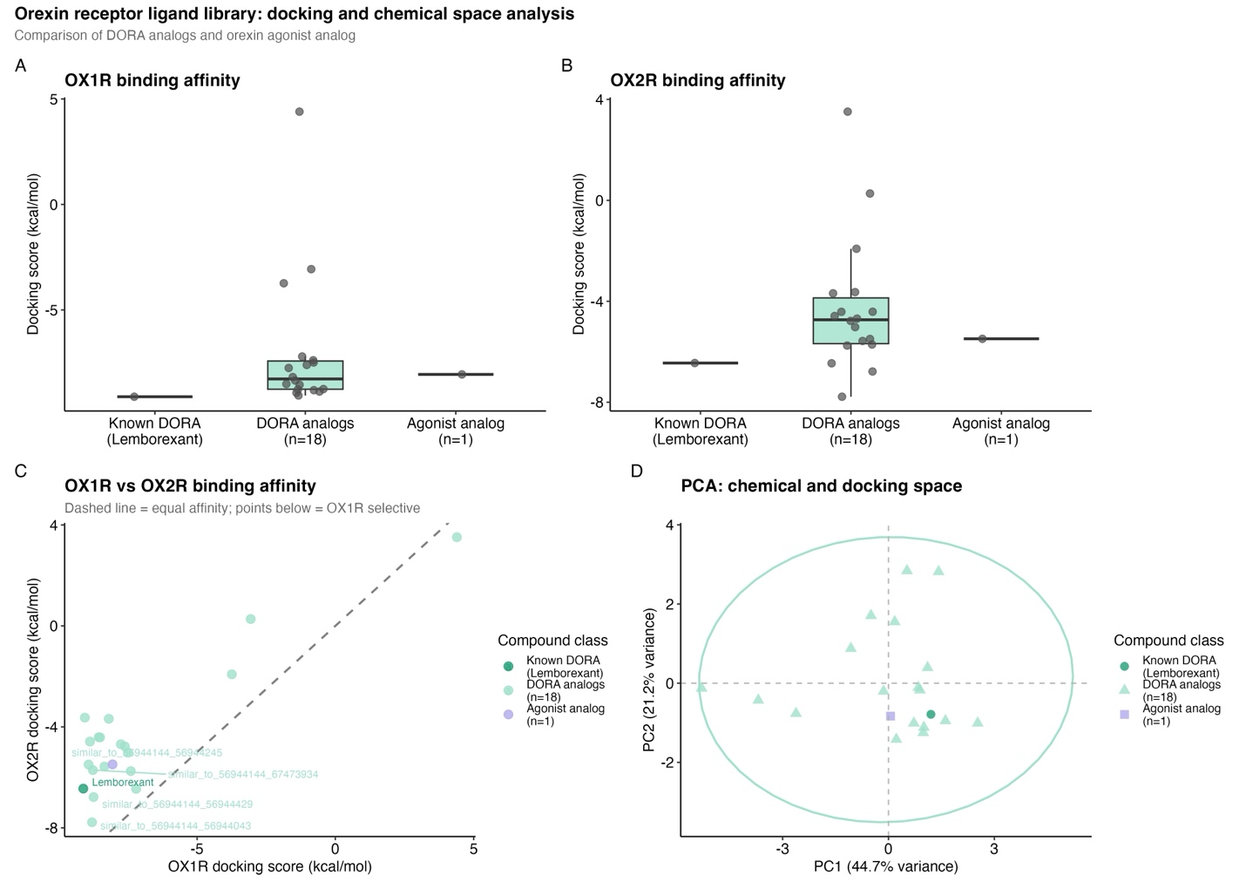
Figure 2. Molecular docking and chemical space analysis of the orexin receptor ligand library. (A) OX1R and (B) OX2R docking scores (kcal/mol) by structural class. Individual compounds are shown as overlaid points; more negative scores indicate stronger predicted binding. (C) OX1R versus OX2R docking scores for all shortlisted compounds. The dashed diagonal line represents equal affinity for both receptors; points below the line indicate OX1R selectivity. Labels identify compounds with mean docking scores more negative than −7.0 kcal/mol. (D) Principal component analysis of eight molecular and docking features. The ellipse represents a 95% normal confidence interval for the DORA analog class. PC1 and PC2 collectively explain 65.9% of total variance.
3.4 Molecular Docking: OX2R Binding and Selectivity
Docking against OX2R (PDB: 4S0V) yielded a narrower range of scores than OX1R, spanning from −7.780 to +3.514 kcal/mol. Lemborexant scored −6.446 kcal/mol at OX2R, consistent with its known dual-receptor pharmacology. The compound achieving the highest composite drug-likeness score, CID 67473934 (Compound 23 in Yoshida et al., 2015), returned an OX2R docking score of −5.712 kcal/mol.
Among compounds successfully docking to both receptors, all demonstrated preferential OX1R engagement, as reflected by negative selectivity indices (ΔG_OX1R − ΔG_OX2R) across the shortlist (range −0.746 to −5.422 kcal/mol).
The most balanced dual-binding profile was observed for a lemborexant scaffold analog (CID 56944043), with OX1R and OX2R scores of −8.796 and −7.780 kcal/mol respectively and a selectivity index of −1.016 kcal/mol: the closest to true dual antagonism observed in the screen. This compound, differing from lemborexant by one methyl group, corresponds to Compound 38 in Yoshida et al. (2015), which reported experimental Ki values of 2 nM (OX1R) and 4 nM (OX2R) and an hERG IC50 exceeding 10 μM. By contrast, five other lemborexant analogs showed strong OX1R preference, with selectivity indices more negative than −4.0 kcal/mol (range −4.09 to −5.42), suggesting partial scaffold divergence toward OX1R selectivity.
The three suvorexant-derived analogs that failed OX1R docking similarly failed at OX2R, returning positive scores, confirming that their poor performance reflects a fundamental incompatibility with the binding site geometry common to both receptors rather than receptor-specific factors (Figures 2B and 2C). The structural basis for this divergence is illustrated in Figure 4.
Notably, the compound with the strongest OX1R score (CID 56944044, −9.057 kcal/mol) also exhibited the greatest OX1R selectivity (index = −5.422), suggesting a structural feature that simultaneously enhances OX1R affinity and reduces OX2R engagement.

3.5 Chemical Space Analysis
Principal component analysis was performed on eight molecular and docking features (MW, XLogP, TPSA, composite score, BBB penetration, hERG liability, OX1R and OX2R docking scores) for the 20 shortlisted compounds. The first two principal components collectively explained 65.9% of total variance, with PC1 accounting for 44.7% and PC2 for 21.2%, indicating that this two-dimensional representation captured the majority of chemical and pharmacological diversity in the shortlist.
Lemborexant was positioned at the core of the DORA analog confidence ellipse (Figure 2D), confirming that the similarity search faithfully recovered analogs occupying the same region of combined chemical and pharmacological space as the parent compound. The three suvorexant-derived analogs that failed docking separated from the main lemborexant analog cluster along PC1, consistent with their poor docking performance and suggesting that the suvorexant scaffold occupies a distinct region of CNS-drug-like chemical space.
An unexpected finding emerged in the positioning of the agonist analog, which clustered in close proximity to lemborexant in the PCA plot despite belonging to a pharmacologically distinct compound class. This proximity indicates substantial overlap in the combined molecular property and docking profile of this agonist analog with the DORA class, a finding that warrants further investigation given the functional distinction between receptor agonism and antagonism.

3.6 Correlation Analysis and Statistical Tests
Spearman rank correlations were computed across nine molecular and docking properties for the 20 shortlisted compounds (Figure 3). Two correlations reached statistical significance. Molecular weight was positively correlated with OX1R docking score (ρ = 0.61, p = 0.004), indicating that heavier compounds tended to achieve stronger predicted OX1R binding. This is consistent with larger molecules making more van der Waals contacts within the binding pocket. hERG cardiac liability was similarly correlated with OX1R affinity (ρ = 0.58, p = 0.008), revealing a potential safety concern: the structural features driving tighter OX1R binding partially overlap with those conferring hERG channel inhibition risk.
A notable negative correlation was observed between composite drug-likeness score and OX1R docking score (ρ = −0.54), indicating that compounds scoring higher on CNS drug-likeness criteria tended to show weaker predicted OX1R binding. This inverse relationship represents a central tension in the dataset: the molecular properties most favorable for CNS drug development appear to work against maximal receptor engagement. This has direct implications for lead optimization strategies in this chemical series.

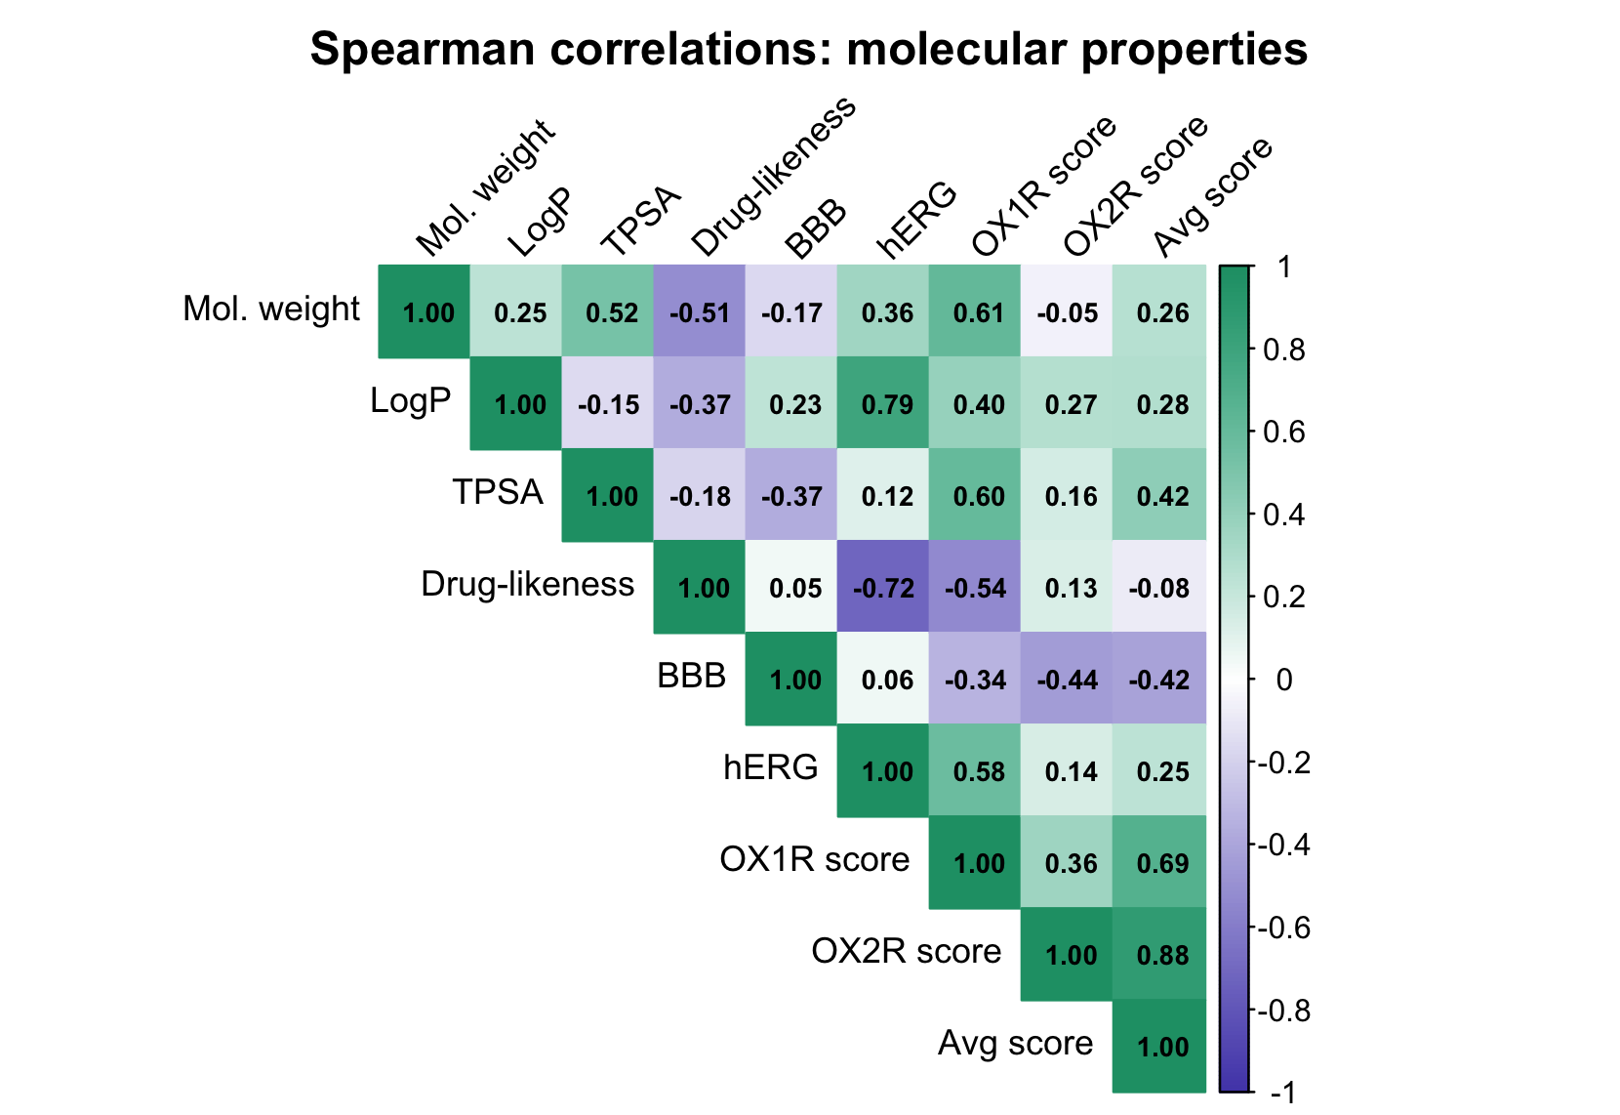

Figure 3. Spearman rank correlation matrix of nine molecular and docking properties across the shortlisted compounds. Color intensity reflects correlation strength; blue indicates negative correlation and green indicates positive correlation. Correlation coefficients are shown within each cell.

TPSA also showed a positive correlation with OX1R score (ρ = 0.60), a counterintuitive finding given that lower TPSA is generally favored for CNS penetration. This suggests that within the lemborexant scaffold series, polar surface area may contribute to binding pocket contacts rather than simply acting as a CNS penetration barrier.
Two-sided Wilcoxon rank-sum tests comparing OX1R and OX2R docking scores between the DORA and DORA analog groups yielded non-significant results (OX1R: W = 0, p = 0.121; OX2R: W = 3, p = 0.315). These results should be interpreted cautiously given the severe imbalance in group sizes (n = 1 DORA vs n = 18 DORA analogs), which substantially limits statistical power.
Despite non-significant group differences, the descriptive data in mean OX1R scores reveals a bimodal pattern within the DORA analog group: high-performing lemborexant-derived analogs approached lemborexant's benchmark score of −9.113 kcal/mol, while three suvorexant-derived analogs with near-zero scores substantially depressed the class mean to −7.03 ± 3.31 kcal/mol. The large standard deviation (± 3.31) reflects this internal heterogeneity rather than uniform analog performance (Table 3).

Table 3. Statistical tests comparing docking scores between structural classes and testing associations with molecular properties.
Comparison | Test | Statistic | p-value
DORA vs DORA analog, OX1R score | Wilcoxon | W = 0 | 0.121
DORA vs DORA analog, OX2R score | Wilcoxon | W = 3 | 0.315
MW vs OX1R score | Spearman | ρ = 0.610 | 0.004
hERG vs OX1R score | Spearman | ρ = 0.579 | 0.008

4. Discussion
In this study, a PubChem-derived library of orexin receptor ligands was assembled and virtually screened using physicochemical filtering, ADMET prediction, composite scoring, and molecular docking to identify compounds with favorable CNS drug-likeness profiles. The screen revealed that lemborexant analogs dominated the candidate shortlist, with several achieving competitive predicted binding affinity at both orexin receptor subtypes. However, the analysis also revealed an inherent trade-off between CNS drug-likeness and receptor binding affinity, and highlighted limitations of rigid docking in predicting subtype selectivity. These findings have implications for lead optimization strategies in orexin receptor drug discovery.
Lemborexant ranked 8th of 79 compounds by composite CNS drug-likeness score. (For comparison, suvorexant ranked 42nd, daridorexant 64th, and oveporexton 74th.) Recovering a clinically approved orexin antagonist near the top of the automated, criteria-based ranking provides internal validation that the scoring scheme captured known favorable CNS properties. Notably absent from this study’s raw library, however, was the dual-binding alkaloid identified by He et al. (2023) and the selective OX1R antagonist reported by Hellmann et al. (2020), reflecting how the scaffold-focused nature of similarity-based library construction may identify complementary candidates by exploring a broader chemical space.
Independently however, the similarity search did retrieve the highest composite CNS drug-likeness score for compound CID 67473934 (Figure 4B) which matches Compound 23 in Yoshida et al. (2015). This provides external validation that the pipeline recovered compounds from the same medicinal chemistry program that produced lemborexant.
Yoshida, however, reported experimental binding affinities for Compound 23 at both orexin receptor subtypes (OX1R Ki = 1016 nM; OX2R Ki = 80 nM; approximately 12-fold OX2R selectivity), while this study predicted stronger OX1R engagement (OX1R = −8.766 kcal/mol; OX2R −5.712 kcal/mol). This misprediction likely reflects both the high structural homology of the two binding pockets which differ by only a few residues notably (Ballesteros-Weinstein numbering) position 3.33 where OX1R carries alanine and OX2R carries threonine. Subtle side-chain and backbone rearrangements determining subtype selectivity are likely not captured by the rigid receptor model used in this study; such limitations are well documented for GPCR subtype discrimination. Noteably, water molecules were removed in this study’s docking model. While water removal is a standard approach to initial virtual docking explorations, crystallographic waters have been shown to significantly influence OX1R/OX2R selectivity (Rappas et al., 2020).
The most balanced dual-binding analog, CID 56944043, (Figure 4B) (OX1R −8.796 kcal/mol, OX2R −7.780 kcal/mol), has also been previously reported (Compound 38 in Yoshida et al., 2015) with Yoshida’s experimental binding affinities of Ki = 2 nM (OX1R) and Ki = 4 nM (OX2R) matching this study’s predicted slight preference for OX1R and confirming potent dual-receptor engagement. Furthermore, Yoshida et al, (2015) reported compound 38’s hERG IC50 exceeds 10 μM, indicating favorable cardiac safety. In this study, CID 56944043 scored well at 12th place in composite CNS drug-likeness. These experimental data provide strong external validation that the computational pipeline correctly prioritized a pharmacologically compelling candidate.
The lemborexant scaffold consistently dominated the results: it was present in 18 of the 20 shortlist positions, concentrated among the top OX1R docking scores, and yielded the best dual-binding candidate. This pattern was observed across ranking, docking, and PCA analyses. By contrast, three suvorexant-derived analogs failed to dock at either OX1R or OX2R, a robust negative outcome likely reflecting scaffold-level structural differences—suvorexant’s diazepane core versus lemborexant’s cyclopropane carboxamide—such that the 0.85 Tanimoto similarity threshold retrieved suvorexant analogs that diverged sufficiently in three-dimensional geometry to be incompatible with the binding sites (Figure 4). This outcome is perhaps unsurprising given that suvorexant and lemborexant, despite sharing a pharmacological target, differ substantially in their core scaffolds. PCA placed those three suvorexant analogs as clear PC1 outliers (Figure 2D), visually corroborating their separation from the lemborexant cluster. These findings underscore that scaffold identity critically influences virtual screening performance within a pharmacological class: two approved DORAs can produce qualitatively different ensembles of dockable, CNS-favorable analogs.

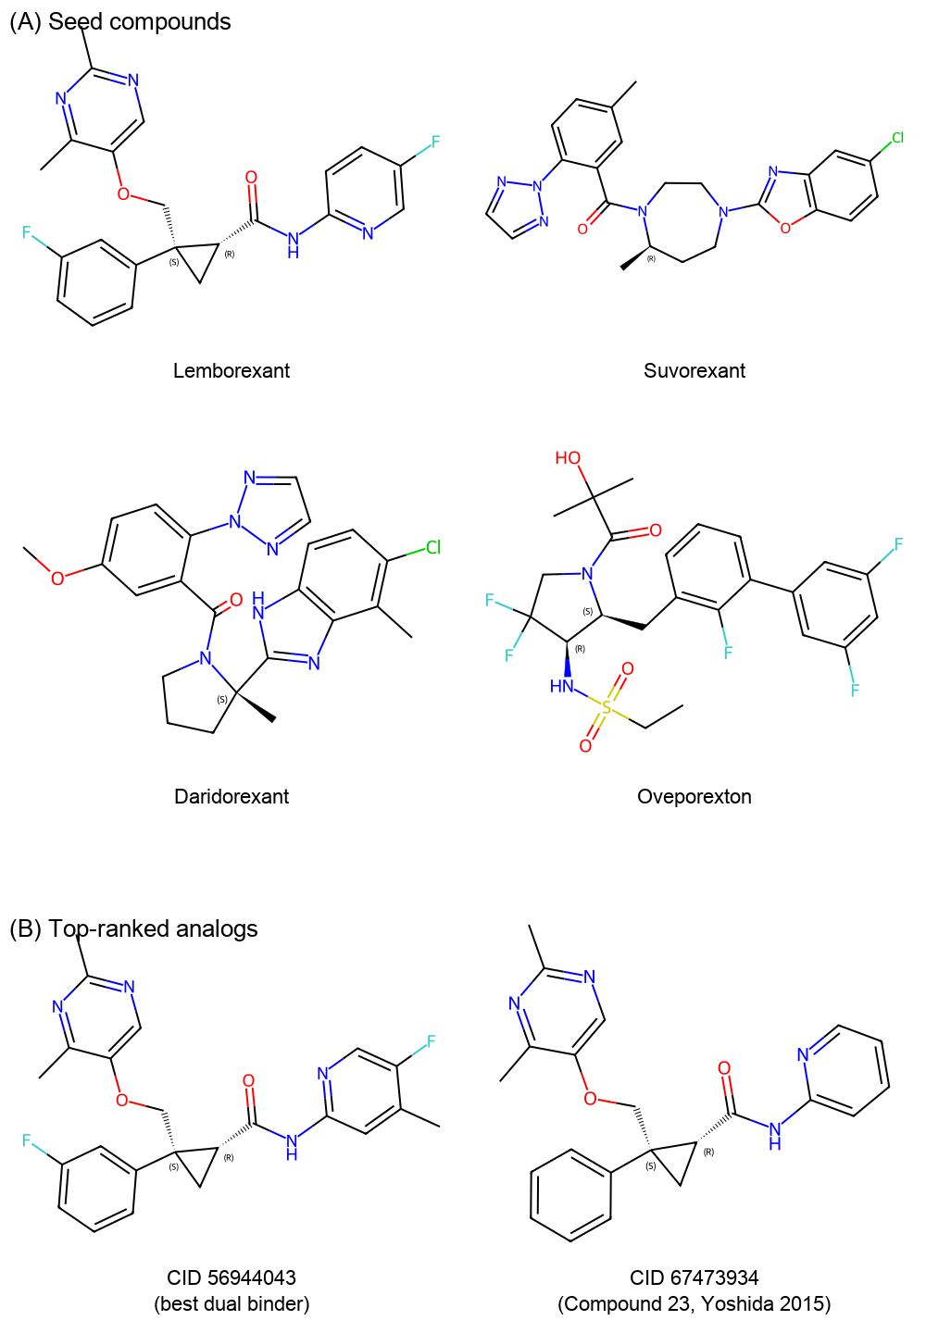

Figure 4. Two-dimensional structural representations of orexin receptor ligands. (A) The four seed compounds used to construct the library: the approved dual orexin receptor antagonists daridorexant, lemborexant, and suvorexant, and the investigational orexin receptor agonist oveporexton. (B) Two top candidate analogs identified in this study: CID 56944043 (Compound 38, Yoshida et al., 2015), which achieved the most balanced dual-receptor docking profile (OX1R −8.796 kcal/mol, OX2R −7.780 kcal/mol) with reported experimental binding affinities of Ki = 2 nM (OX1R) and Ki = 4 nM (OX2R); and CID 67473934 (Compound 23, Yoshida et al., 2015), which achieved the highest composite drug-likeness score in the library. Structures generated using RDKit.

The negative association between composite drug-likeness and OX1R docking score (ρ = −0.54, Figure 3) indicates that compounds scoring highest for CNS suitability generally showed weaker predicted OX1R binding. Although the OX1R pocket is largely hydrophobic, CNS-favorable compounds, which are typically smaller and lipophilic, may underfill the binding site and lack key polar anchoring interactions, reducing predicted affinity. Larger lipophilic molecules can make more extensive hydrophobic contacts and score better in docking, at the expense of BBB-penalizing properties. This size-affinity trade-off is well recognized in CNS drug discovery (Wager et al., 2010).
Notably this negative correlation was specific to OX1R. The analogous correlation with OX2R docking score was negligible (ρ = 0.13) suggesting that the OX2R binding pocket may be more structurally accommodating of CNS-favorable molecular properties than OX1R.
Accordingly, compounds that strike a balance between these competing demands, such as CID 56944043, represent attractive starting points for optimization, occupying a productive compromise between composite drug-likeness and receptor engagement.
Of concern was hERG cardiac liability correlating positively with OX1R docking score (ρ = 0.58, p = 0.008, Table 3), indicating that compounds predicted to bind more tightly to OX1R also tended to carry higher predicted risk for hERG channel inhibition. This aligns with the known mechanism whereby larger, more lipophilic molecules making extensive hydrophobic contacts in protein pockets can also block the hERG potassium channel, a major safety liability linked to potentially fatal cardiac arrhythmias. This overlap between desirable binding features and hERG risk is a well-recognized challenge in CNS drug discovery.
Separately, the agonist class exhibited elevated predicted mutagenicity (AMES probability 0.701 ± 0.157) compared to DORA analogs (0.280 ± 0.154), representing an additional safety distinction between pharmacological classes that warrants experimental investigation. These in silico safety flags do not eliminate candidates but prioritize experimental follow-up; compounds such as CID 56944043, which combine competitive docking with moderate hERG predictions, warrant progression as balanced starting points for optimization.
One agonist analog made the shortlist and docked competitively (OX1R −8.056 kcal/mol; OX2R −5.485 kcal/mol), clustering near lemborexant in PCA space despite its distinct pharmacology (Figure 2D). This PCA proximity likely reflects similarity with the antagonist in combined physicochemical and docking profiles rather than in shared mechanisms, with both occupying similar chemical space yet interacting with the receptor differently at the molecular level. Its appeal is tempered by the elevated predicted mutagenicity observed across the agonist class (AMES probability 0.701 ± 0.157) The finding raises the testable question of whether the orexin binding pocket can accommodate both agonists and antagonists with similar physicochemical profiles, a question resolvable only by experimental characterization.
Several computational and methodological limitations warrant consideration. Rigid receptor docking, employed here for efficiency, cannot capture the side-chain and backbone rearrangements that determine subtype selectivity between closely homologous binding pockets. Future work should incorporate flexible docking or molecular dynamics ensemble approaches to sample receptor conformational variability. Furthermore, all crystallographic water molecules were removed prior to docking, whereas published structural analyses have demonstrated that waters in the orexin binding pocket significantly influence subtype selectivity (Rappas et al., 2020). This factor may have contributed to the observed selectivity misprediction for CID 67473934.
The small docking shortlist (n = 20) which contained only a single approved DORA as a reference compound limited statistical power and generalizability; expanding the library, lowering the Tanimoto similarity threshold below 0.85, and including additional reference DORAs would enable more robust comparative statistics. ADMET endpoints were machine learning estimates generated by admet-ai and carry inherent uncertainty; experimental ADMET profiling should be prioritized for high-ranking candidates before medicinal chemistry investment.
Biological limitations are equally important to acknowledge. Both receptor structures represent single crystallographic snapshots, whereas GPCRs are conformationally dynamic and may present alternative binding pocket geometries under physiological conditions; incorporating multiple receptor conformations from molecular dynamics simulations or cryo-EM ensembles would provide a more realistic representation of the docking landscape. Most critically, all findings reported here are in silico predictions: predicted binding affinities, selectivity indices, and safety flags require empirical validation through biochemical binding assays, functional cellular assays, and in vitro safety testing (hERG electrophysiology, Ames mutagenicity, ADME profiling) before any candidate can be considered a confirmed lead for medicinal chemistry optimization.

5. Conclusions and future directions
This study demonstrates that an automated CNS-focused virtual screening pipeline can efficiently prioritize orexin receptor ligands: the lemborexant scaffold dominated shortlist performance, CID 56944043 emerged as a promising dual-binding candidate, and a persistent trade-off between composite drug-likeness and OX1R receptor binding affinity emerged as a central pharmacological insight.
Next steps should prioritize experimental binding and functional assays for CID 56944043 and the top lemborexant analogs, alongside flexible docking or molecular dynamics simulations to refine OX1R/OX2R selectivity predictions. Synthesis and in vitro ADME and toxicity profiling of prioritized compounds would provide the empirical foundation needed to advance computational leads into medicinal chemistry optimization. These targeted validations will clarify which computational leads translate to tractable chemical series. More broadly, this work illustrates how automated CNS-focused virtual screening pipelines can efficiently identify literature-relevant scaffolds and balanced lead candidates for GPCR targets.

Acknowledgments
The author thanks Adjunct Instructor Yury Bukhman, Bioinformatics, University of Wisconsin-Platteville, for project guidance and support.

References
Arif, Z., Siddiqui, E., Hujjat, S. F. Z., Khan, M. S., & Mauhmoud, A. (2025). Orexin receptor 2 agonists: A pathophysiologic approach to narcolepsy type 1. Annals of Medicine and Surgery, 88(1), 42–44. https://doi.org/10.1097/MS9.0000000000004476
Chekani, F., Mirchandani, K., Zaki, S., Goswami, S., & Sharma, M. (2025). Utilization of potentially inappropriate sedative-hypnotic and atypical antipsychotic medications among elderly individuals with insomnia and Alzheimer's disease. Sleep, 48(4), zsaf003. https://doi.org/10.1093/sleep/zsaf003
Dauvilliers, Y., Plazzi, G., Mignot, E., Lammers, G. J., Del Río Villegas, R., Khatami, R., Taniguchi, M., Abraham, A., Hang, Y., Kadali, H., Lamberton, M., Sheikh, S., Stukalin, E., Neuwirth, R., Swick, T. J., Tanaka, S., von Hehn, C., von Rosenstiel, P., Wang, H., & Olsson, T. (2025). Oveporexton, an oral orexin receptor 2-selective agonist, in narcolepsy type 1. The New England Journal of Medicine, 392(19), 1905–1916. https://doi.org/10.1056/NEJMoa2405847
Eberhardt, J., Santos-Martins, D., Tillack, A. F., & Forli, S. (2021). AutoDock Vina 1.2.0: new docking methods, expanded force field, and python bindings. Journal of Chemical Information and Modeling, 61(8), 3891–3898. https://doi.org/10.1021/acs.jcim.1c00203
Gayger-Dias, V., Krebs-Rosa, J., Bobermin, L. D., Quincozes-Santos, A., & Gonçalves, C.-A. (2026). Zolpidem may affect glial flow in addition to norepinephrine-mediated vasomotility of the glymphatic system. CNS Drugs, 40(3), 279–281. https://doi.org/10.1007/s40263-025-01269-2
Hauglund, N. L., Andersen, M., Tokarska, K., Radovanovic, T., Kjaerby, C., Sørensen, F. L., Bojarowska, Z., Untiet, V., Ballestero, S. B., Kolmos, M. G., Weikop, P., Hirase, H., & Nedergaard, M. (2025). Norepinephrine-driven slow vasomotion drives glymphatic clearance in sleep. Cell, 188(3), 606-622.e17. https://doi.org/10.1016/j.cell.2024.11.027
He, J., Fang, J., Wang, Y., Ge, C., Liu, S., & Jiang, Y. (2023). Discovery of small-molecule antagonists of orexin 1/2 receptors from traditional Chinese medicinal plants with a hypnotic effect. Pharmaceuticals, 16(4), 542. https://doi.org/10.3390/ph16040542
Hellmann, J., Drabek, M., Yin, J., Gunera, J., Pröll, T., Kraus, F., Langmead, C. J., Hübner, H., Weikert, D., Kolb, P., Rosenbaum, D. M., & Gmeiner, P. (2020). Structure-based development of a subtype-selective orexin 1 receptor antagonist. Proceedings of the National Academy of Sciences, 117(30), 18059–18067. https://doi.org/10.1073/pnas.2002704117
Järvelä, M., Kananen, J., Helakari, H., Korhonen, V., Huotari, N., Väyrynen, T., Hautamäki, K., Raitamaa, L., Tuunanen, J., Kallio, M., Piispala, J., Ansakorpi, H., & Kiviniemi, V. (2025). Orexin effect on physiological pulsations of the human brain. Proceedings of the National Academy of Sciences, 122(31), e2501578122. https://doi.org/10.1073/pnas.2501578122
Kim, S., Chen, J., Cheng, T., Gindulyte, A., He, J., He, S., Li, Q., Shoemaker, B. A., Thiessen, P. A., Yu, B., Zaslavsky, L., Zhang, J., & Bolton, E. E. (2023). PubChem 2023 update. Nucleic Acids Research, 51(D1), D1373–D1380. https://doi.org/10.1093/nar/gkac956
Majumdar, S., Chiu, Y.-T., Pickett, J. E., & Roth, B. L. (2024). Illuminating the understudied GPCR-ome. Drug Discovery Today, 29(3), 103848. https://doi.org/10.1016/j.drudis.2023.103848
Mieda, M., Tsujino, N., & Sakurai, T. (2013). Differential roles of orexin receptors in the regulation of sleep/wakefulness. Frontiers in Endocrinology, 4. https://doi.org/10.3389/fendo.2013.00057
Ragsdale, S. M., Radovich, J. M., Coiduras, I. I., McCall, W. V., Grant, S. C., Lee, C., & Wilber, A. (2025). Dual orexin receptor antagonists as promising therapeutics for Alzheimer's disease. Npj Biological Timing and Sleep, 2(1), 11. https://doi.org/10.1038/s44323-025-00025-5
Rappas, M., Ali, A. A. E., Bennett, K. A., Brown, J. D., Bucknell, S. J., Congreve, M., Cooke, R. M., Cseke, G., De Graaf, C., Doré, A. S., Errey, J. C., Jazayeri, A., Marshall, F. H., Mason, J. S., Mould, R., Patel, J. C., Tehan, B. G., Weir, M., & Christopher, J. A. (2020). Comparison of orexin 1 and orexin 2 ligand binding modes using X-ray crystallography and computational analysis. Journal of Medicinal Chemistry, 63(4), 1528–1543. https://doi.org/10.1021/acs.jmedchem.9b01787
Sena, C., Albuquerque, P., Oliveira, J., & Vieira, D. (2025). Molecular insights into the interaction of orexin 1 receptor antagonists: a comprehensive study using classical and quantum computational methods. Molecules, 30(13), 2790. https://doi.org/10.3390/molecules30132790
Smart, D., Jerman, J. C., Brough, S. J., Rushton, S. L., Murdock, P. R., Jewitt, F., Elshourbagy, N. A., Ellis, C. E., Middlemiss, D. N., & Brown, F. (1999). Characterization of recombinant human orexin receptor pharmacology in a Chinese hamster ovary cell-line using FLIPR. British Journal of Pharmacology, 128(1), 1–3. https://doi.org/10.1038/sj.bjp.0702780
Swanson, K., Walther, P., Leitz, J., Mukherjee, S., Wu, J. C., Shivnaraine, R. V., & Zou, J. (2024). ADMET-AI: a machine learning ADMET platform for evaluation of large-scale chemical libraries. Bioinformatics, 40(7), btae416. https://doi.org/10.1093/bioinformatics/btae416
Trott, O., & Olson, A. J. (2010). AutoDock Vina: improving the speed and accuracy of docking with a new scoring function, efficient optimization, and multithreading. Journal of Computational Chemistry, 31(2), 455–461. https://doi.org/10.1002/jcc.21334
Wager, T. T., Hou, X., Verhoest, P. R., & Villalobos, A. (2010). Moving beyond rules: the development of a central nervous system multiparameter optimization (CNS MPO) approach to enable alignment of druglike properties. ACS Chemical Neuroscience, 1(6), 435–449. https://doi.org/10.1021/cn100008c
Yoshida, Y., Naoe, Y., Terauchi, T., Ozaki, F., Doko, T., Takemura, A., Tanaka, T., Sorimachi, K., Beuckmann, C. T., Suzuki, M., Ueno, T., Ozaki, S., & Yonaga, M. (2015). Discovery of (1R,2S)-2-{[(2,4-dimethylpyrimidin-5-yl)oxy]methyl}-2-(3-fluorophenyl)-N-(5-fluoropyridin-2-yl)cyclopropanecarboxamide (E2006): a potent and efficacious oral orexin receptor antagonist. Journal of Medicinal Chemistry, 58(11), 4648–4664. https://doi.org/10.1021/acs.jmedchem.5b00217
Żełabowski, K., Petrov, W., Wojtysiak, K., Ratka, Z., Biedka, K., Wesołowski, M., Fus, K., Ślebioda, D., Rusinek, M., Sterkowicz, M., Radzka, I., & Chłopaś-Konowałek, A. (2025). Targeting the orexin system in the pharmacological management of insomnia and other diseases: suvorexant, lemborexant, daridorexant, and novel experimental agents. International Journal of Molecular Sciences, 26(17), 8700. https://doi.org/10.3390/ijms26178700

